**DEMOGRAPHICS IMPACT**

The increasing elderly people in future will lead to more income and the increasing **life expectancy** of old people due to good health facilities will lead to more issuance of insurance policies in **Retirement Policies**. Hence it is beneficial for the life insurance companies to grow and tap the under penetrated market.

Age of **20-64 population** will be large by 2050 so need **Protection plans.**

**PROTECTION GAP :** Economic loss that people will suffer – Life insured Coverage

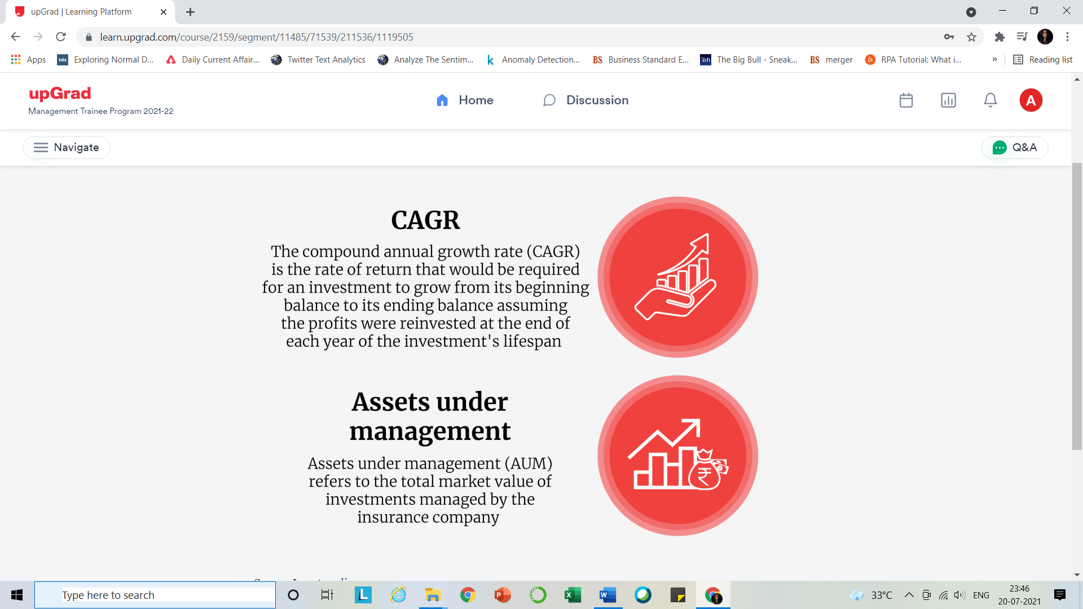

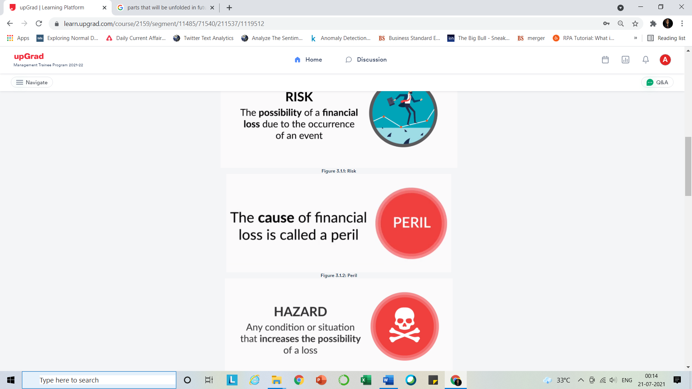

**RISK MANAGEMENT : C**ontrol **, A**void**, R**etention **, T**ransfer.

**How can loss be predictable?**

When we say 'losses should be predictable', it means that the frequency and the average severity of the occurrence of risks that lead to such losses should be statistically determinable.

The insurance industry has statistical data on the frequency of occurrence of deaths, illnesses, natural calamities, etc. Based on this data, these companies can predict the amount of losses that could be incurred in the current year or in the future. For example, when we say that the mortality rate is 0.1% at the age of 25, it means 1 person out of every 1,000 persons insured at the age of 25 will die during the year. However, who out of those 1,000 people will die cannot be statistically predicted. Hence, though the frequency of the occurrence of risk is predictable, who will bear the financial losses due to this risk is not known. Thus, insurance companies can offer insurance to the 25-year-old age group by charging a premium in accordance with the anticipated claim amount.

For events whose frequency and severity cannot be predicted, very less statistical data is available to predict the frequency and/or the average severity of the associated losses, are not insurable. Events like war, communal riots, terrorist attacks, etc. occur infrequently and cause major losses that cannot be quantified or anticipated becuase of their varying nature. Statistically, it is not possible to predict both the frequency and the average severity of such losses and, hence, they cannot be insured.

Some risks like monsoons and floods in Bhiwandi (a village in Thane district) have a high frequency of occurrence and high severity of average losses. While statistically this risk can be priced, the commercial viability of insurance cover is low, as the premiums will be very high. Such risks, though predictable, cannot be insured because such insurance cover will not have commercial viability for the insurance company.

**WITHIN 3 YEARS (NEED ALL INFORMATION)**

Application of the principle of utmost good faith has been limited under  Section 45 of the Insurance Act 1938. The insurance company can cancel the contract or reject the claim on grounds of non-disclosure of material fact within three years from the date of commencement or revival (if applicable) of the policy.

**15 DAYS LOoK IN**  The free look period given by insurance policies is 15 days post receipt of the policy document; if returned, the policyholder will get a refund after deducting some charges.

**PREMIUM TYPES**

1.Single premium

2.Regular premium – Level premium

3Limited premium

**NOMINATION & ASSIGNMENT:** section 39

At the proposal time

Or in future can change the nominee by filling the form

If the beneficiaries die before receiving the claim amount his heirs will receive it.

**Assignment**: The transfer of ownership or changing the policyholder.

WILL(right to own the assets) supsedes Nomination( right to receive- exists as fund transfer from banks and FI becomes hassle free)

**Conditional Assignment:**

* Will revert back to policyholder if assignee dies .
* Effective only when policyholder dies.

**Partial Assignment :** having two policyholder

Assignment for loans means in addition to mortgage homes banks can ask for insurance policies in case loan payer dies so to recover the amount

**BENEFITS:**

1. **Maturity**
2. **Survival**
3. **Death**
4. **Surrender** – discounted paid up value
5. **Loan**
6. **Rider**

**POLICY CONTRACT:**

* 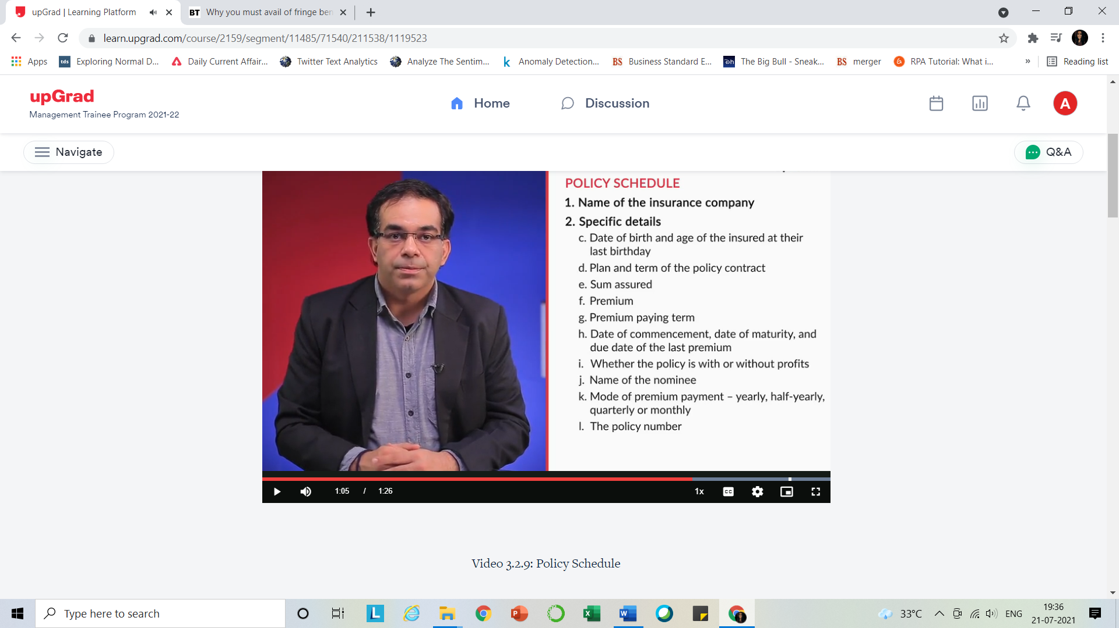**Policy Schedule:**

Basically AN OVERVIEW

3.Insurer’s promise to pay the benefits.

4.Authorized signature and stamp

5. Address of local ombudsman

* **Policy Provisions:** all features of the contract.

1. Rights and privileges
2. Payment and cessation of premium
3. Grace period
4. Lapsation once not paid in grace period it becomes minor lapse policy for 6 months but can be revived with extra charges. Again it is not paid becomes major lapse policy and discontinues.
5. Revival
6. Discontinuance
7. Paid up
8. Surrender
9. Policy Loan – can take loan against policy which will be 80 to 90 percent of surrender value.
10. Alterations are allowed – policy term/sum assured/Premium frequency/Policyholder name/Rider
11. Bonuses
12. Claim Process
13. Free Look Cancellation
14. Tax and terms conditions

* **Specific Policy Provisions :**

**POLICY LIFE CYCLE :**

1. Proposal form is submitted through Financial consultant who determines first level risks to the client
2. Acceptance – Insurer accepts the policy seeing everything is fine.

* It includes UNDERWRITING Stage as well
* 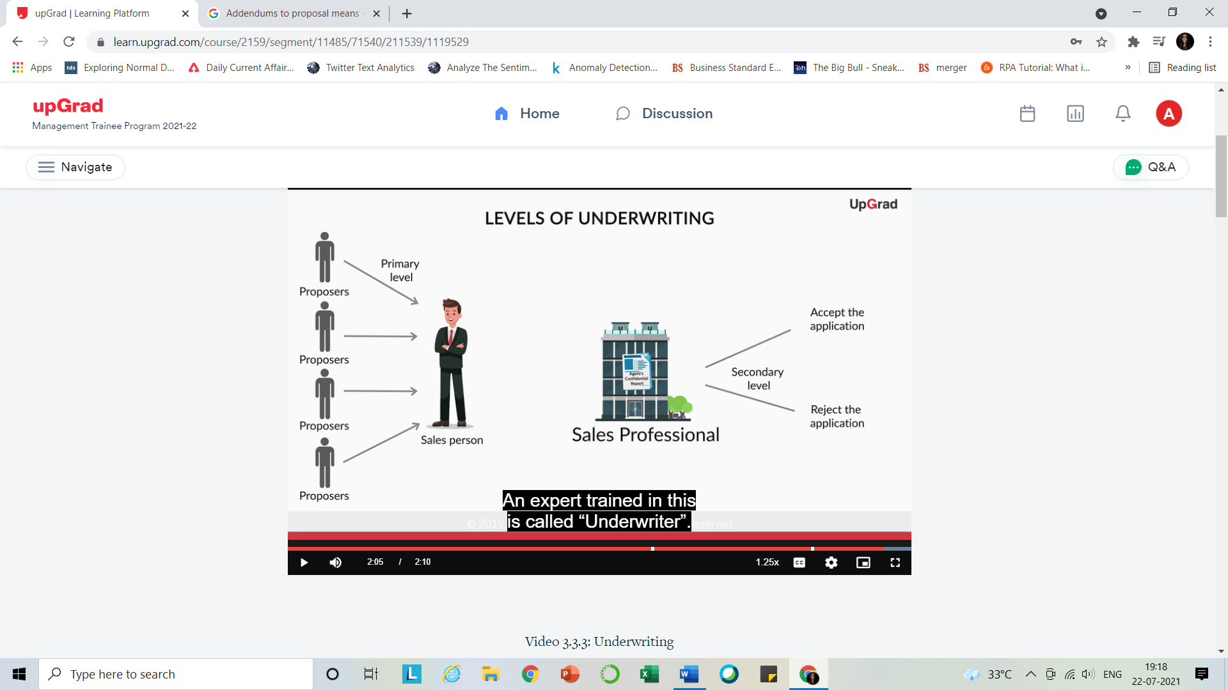

Primary Underwriting - At this level, underwriting is done by the **insurance salesperson** as he or she is in a better position to select the lives for life insurance.

Secondary Underwriting - At this level, underwriting is done at the Life Insurance office by an underwriter, who is an expert trained in this process.

Types of Underwriting

* **Limited** - some health related questions and/or declarations signed by the life assured or policyholder. This is used to underwrite proposals with low risks and in products that are sold on a mass scale and over the counter to customers.
* **Non medica**l - this is done on the basis of answers provided by policyholder to personal questions  in the proposal form. Any risk detected here is then assessed by a trained underwriter. Accepted through a **Straight Through Process**.
* **Medical Underwriting** **-**This is done based on answers provided  to personal questions in the proposal form and the medical reports of the life assured, which are called as per the risk proposed.

1. Policy administration
2. Claims

**RISKS ASSESSED IN UNDERWRITING :**

1.Occupation Risks

2.Residence Risks – Political/Economical/Geographical/Epidemic /

3.Avocation – Hobbies

4.Financial Risk – HLV ,Deciding the premium

5.Moral Hazard –

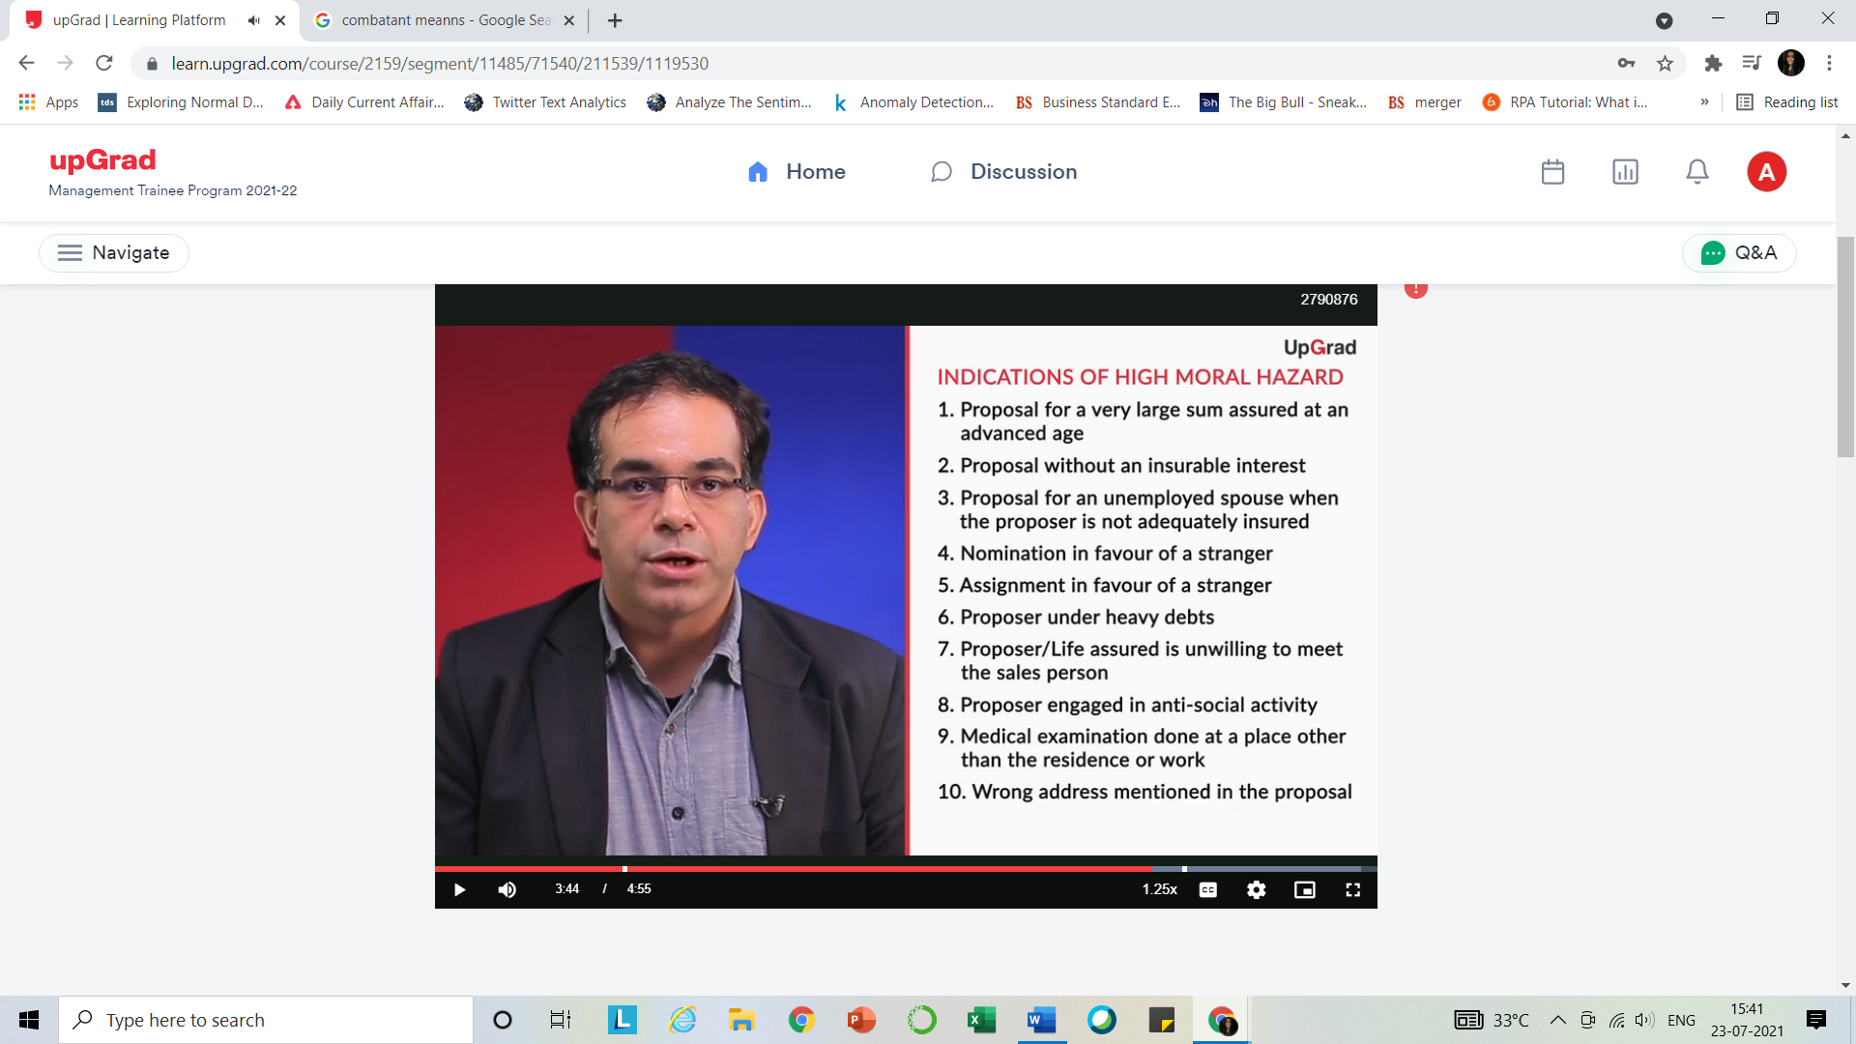

6.Money Laundering Risk

Combatant soldier are charged extra premium whereas Non combatant soldier is

considered standard.

Earlier, you understood how an underwriter assesses risks. Once that is done, the underwriter classifies risks into the following categories.

1. Standard Risks
2. Sub-Standard Risks

The five decisions taken at the end of the underwriting process can be summarised as follows.

1. Accept the proposal at a standard premium
2. Accept the proposal with an extra premium or modified terms or both
3. Accept the proposal with a lien
4. Postpone the proposal
5. Decline the proposal

**CLAIMS & ITS TYPES:**

**CLAIM PROCESS :** Starting from filling the form. And it is necessary only in death claims and sometimes in health claims too.

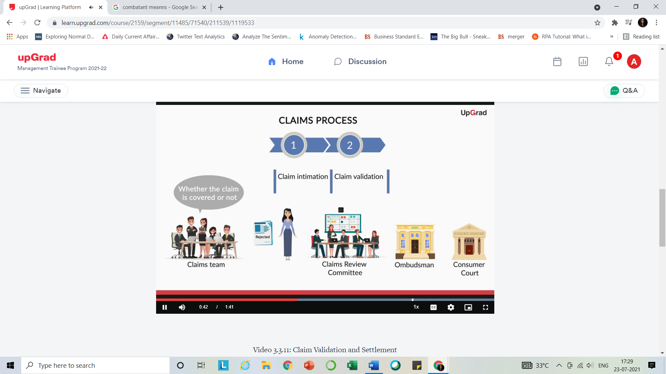

Settlement

**FINANCIAL BASICS**

**Savings –** Postpone the expenditure o future date.

**Investments –** saving with an aim to grow.

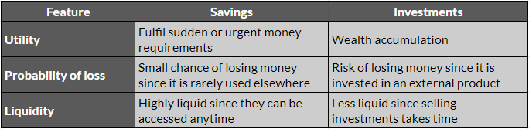

**RISKS – https://www.getsmarteraboutmoney.ca/invest/investing-basics/understanding-risk/types-of-investment-risk/**

1. **INVESTMENT –** To get less return than expected or lose some or all the money.
2. **BANKRUPTCY RISK**
3. **LIQUIDITYY**
4. **CONCENTRATION**
5. **HORIZON**
6. **INFLATION**
7. **FOREIGN INVESTMENT**
8. **REINVESTMENT**
9. **CREDIT**
10. **LONGEVITY**

**RISK PROFILES OF INVESTORS**

1. **Risk-averse**
2. **Conservative**
3. **Balanced**
4. **Growth Oriented**
5. **Aggressive**

**FV/PV OF MONEY**

1. **PV –** it is the present value of all future earnings
2. FV – future value of money compounded.
3. NPV – PV of (INFLOWS-OUTFLOWS)

Positive – profitable invesment

Negative -loss

1. **IRR -** NPV is zero
2. **CAGR -** 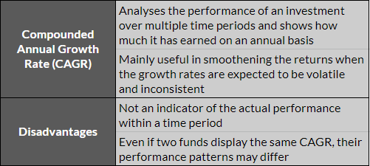To know Y-O-Y Growth of an investment invested for long period of time and where returns are generally volatile.

Beginning and ending value is considered and average out the results of intermediate years.

1. While selecting the projects Cost of Capital<IRR

**FINANCIAL INSRUMENTS**

**1.Diff btwn Financial Instrument and Security –** 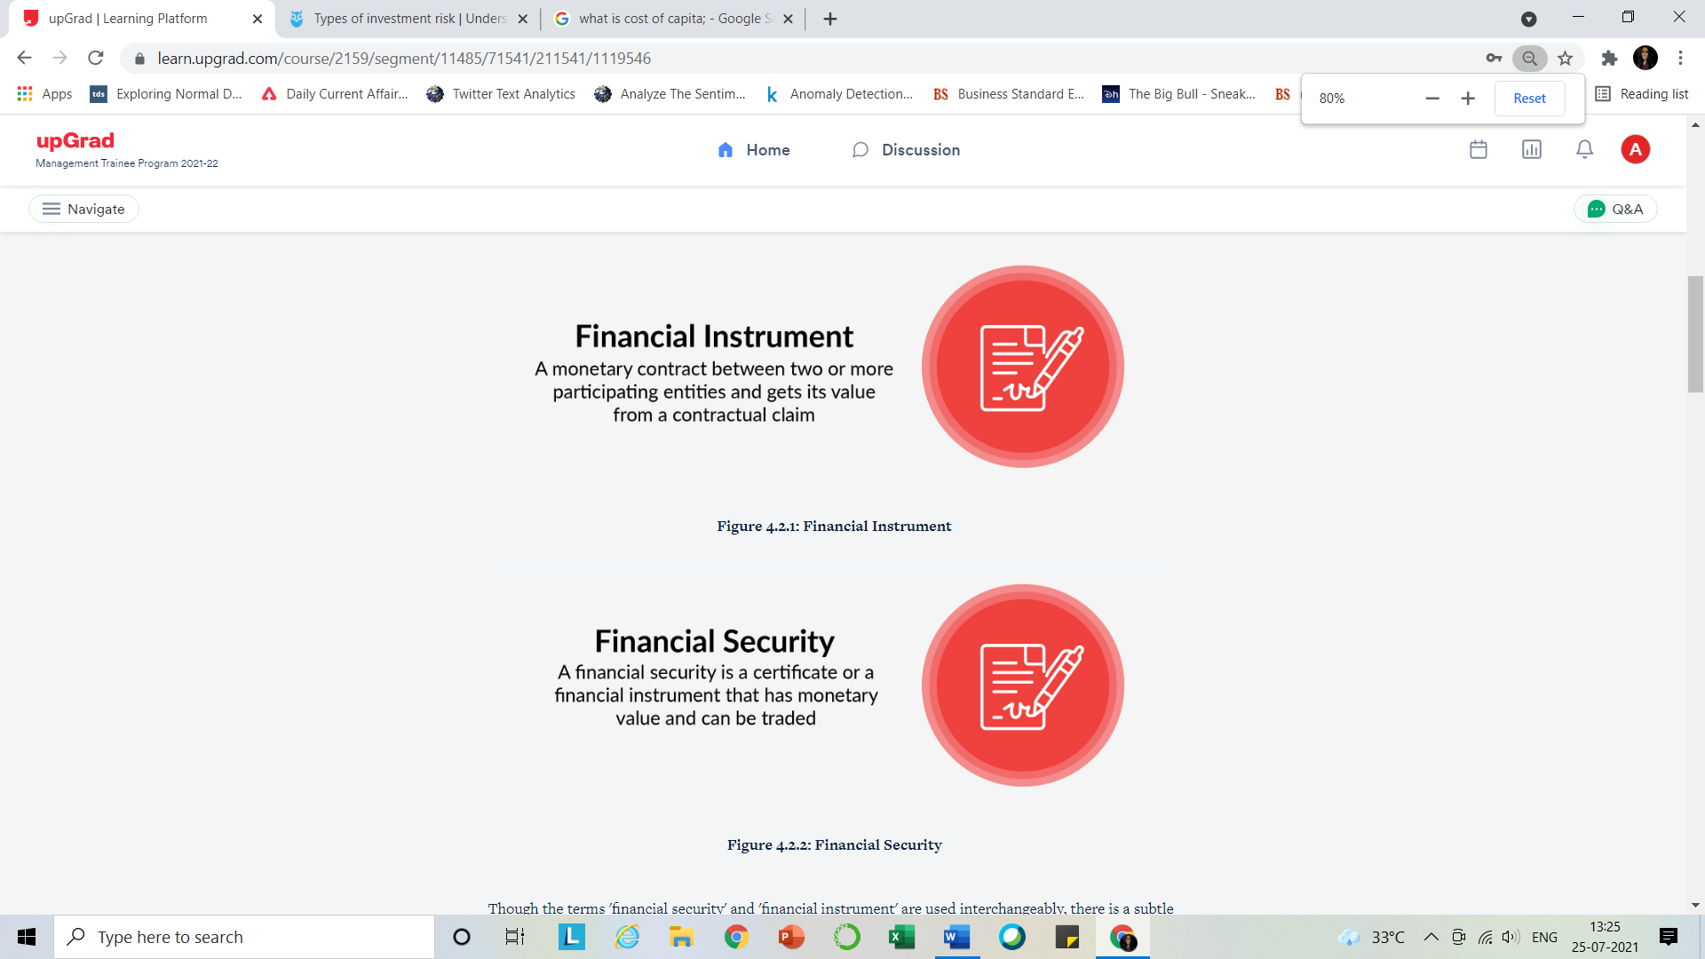

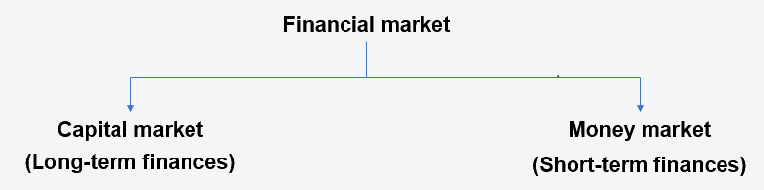

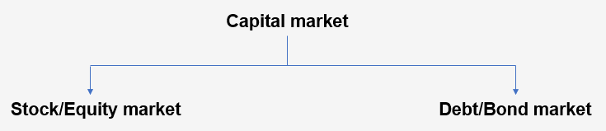

**RIGHTS ISSUE –** to existing shareholders

**Private Placement –** to selected group of investors

**IPO –** to all

**BONDS :**

Coupon Rate,calculated on Face Value

Interest Rtae calculated on Market Value of bonds

Prices are inversely proportional to interest rates(market rate) .As rate increases there will be no buyers for your bonds at higher price with low interest rate…and if price goes down people are ready to pay more for your bond ..

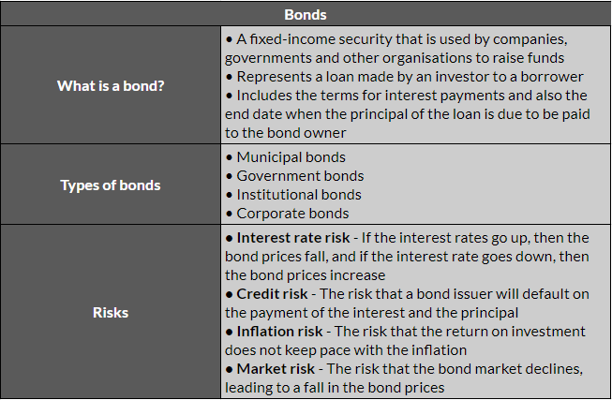

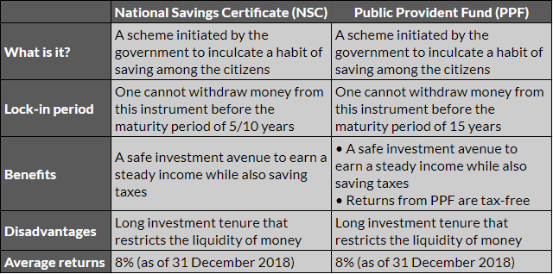

BONDS – Give Tax

DEBENTURES- Give Tax

FD- Give Tax

NSC-Returns are not tax free

PPF-No tax

**EQUITY** 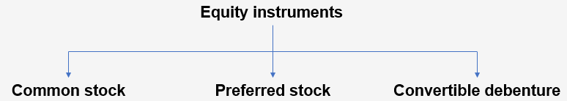

**MONEY MARKET INSTRUMENTS-**

TB – govt

Central and state govt. securities

CD- Corporate/FI

CP- Corporate/FI (For amt grater than 5,00,000)

Repurchase Agreement – only of govt. securities

**MUTUAL FUNDS**

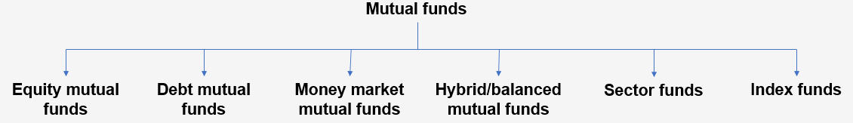

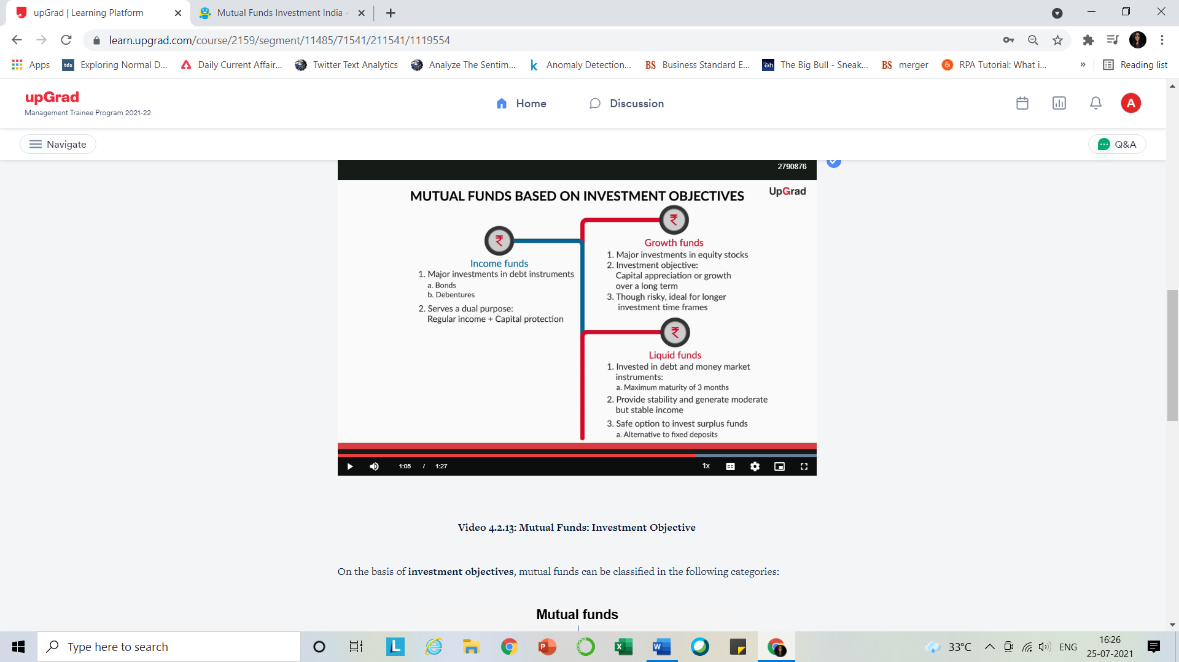

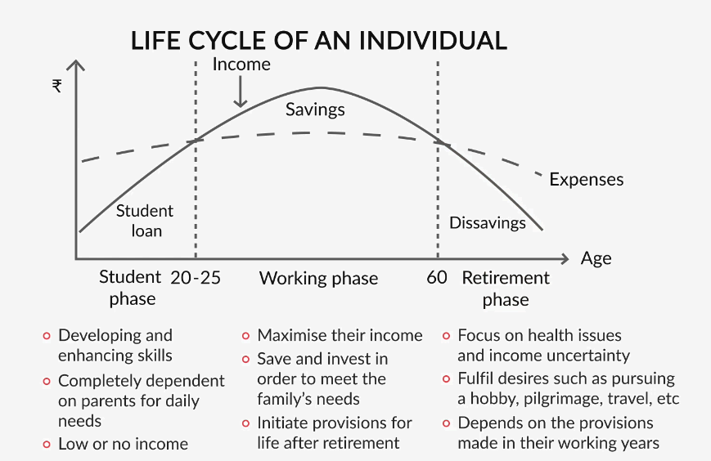

AIM:

1.TO grow wealth

2. save money for enabling future transactions

3.Protection against Uncertainity

4.Retirement

**Dmeand is increasing with population so supply of money increases and inflation .**

**Short term Investment > From short term savings.**

**Long term Investment > From Long term savings.**

Before making an investment, the following factors need to be considered:

1. What is the **liquidity** of this investment?

2. How long will my money be **locked-in** for growth?

3. What is the **risk o**f losing money in this instrument?

4. What is the possible **growth rate** in the investment?

**FINANCIAL PLANNING**

Financial Planning depends on Age

IRR: The return that could be earned in alternative investments

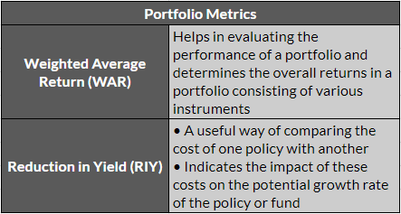

Performance of Portfolio:

WAR

RIY:Return -RIY=Actual Return

My focus : Ideally, financial planning should start from the moment he earns his first salary. As you know, the longer the duration of investment, the more is the growth of the invested money. Instead of spending all his money on leisure activities, he should first develop a financial plan, list down his short-term, medium-term and long-term goals, and work out the amount he will need to save or invest every month in order to meet them.  
After understanding the impact of his current expenditure, he should make a decision about how to spend the money.

Based on the analysis of data over the years, the longer the investment horizon, the higher are the likely returns. This is mainly due to the **compounding nature of invested money.** You have understood this concept in the earlier session on financial terminologies

**INSURANCE**

All Insurance plans are combination of Pure Term and Pure Endowment Plans.Like Car or Mediclaim.

Risk of dying to Soon(Pure Term Plans) / Risk of living too long (Pure Endowment Plan)

**Pure Term Plans** – only on death before maturity

**Pure Endowment** – Only after surviving the term/maturity

**Endowment** – Term+Pure Endowment,where nominee gets death benefit if died before the term and assured will gain survival benefits if survived the term.

**Triple cover Endowment** – 1x pure endowment + 3x Term plan which is equal to 3 times of endowment .

**Money Back** – 1 Term Plan + N (Endowment Plan) where at every nth year some survival benefit is paid.

**Term Insurance**

* The term insurance pays a sum assured in the event of death during the term of the policy. When this sum assured does not change throughout the term, and remains constant, this type of term insurance is called **Level Term Insurance Plan.**
* **Increasing term Insurance** where SA Increases with the policy term.
* **Decreasing term Insurance**
* **Term with a return of Premium –** On survival Policyholder get s all premium returned that he paid
* **Benefits-**
* Low premium but high SA
* Cover Loans

**Whole Life Insurance VS Term Insurance**

Aim: WL focus on leaving a legacy behind whereas TI focus on risk of early death

Premium : WL has high whereas TI has low.

SA: WL has guaranteed SA Whereas no guarantee to get SA in TI

WL insurance is taken generally at high age where term insurance is difficult to get.

**Classification Of Plans**

1.Protection –

* Life (minimum 5 years and have accident and Disability riders as well)
* Health(Indemnity and Fixed benefits Plans) 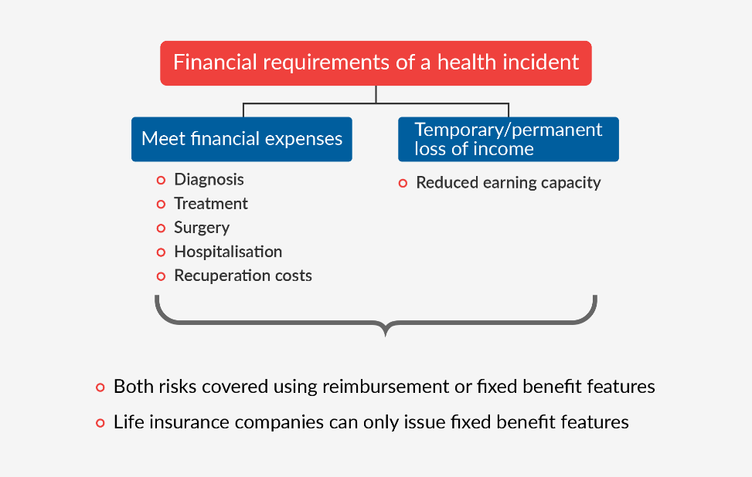

In health insurance there are riders of critical illness which can help people to recover expense as well as lost income for long time as you were hospitalized

* Riders are available

2.Savings – pure+endowment

* Lump sum amount/periodic payments can be chosen
* children education/marriage/Property/Vacation
* provides both death and maturity and premium waiver Benefits as adopted

3.Retirement –

* Accumulation Phase + Pension /Annuity Phase
* Once a corpus is created and term ends then immediately annuity plan is purchased and thereafter annuity is paid.
* Deferred annuity: This is usually purchased by an individual who is a few years away from retirement. It has a time period when the premium is to be paid, but there is no payout; this is called the deferment period. At the end of this period, an annuity is purchased with the accumulated amount, which starts the pension immediately.
* Immediate annuity: This is usually purchased by an individual who is considering immediate retirement, with his/her life savings, to get regular payouts until death.

Classification of Insurance Plans

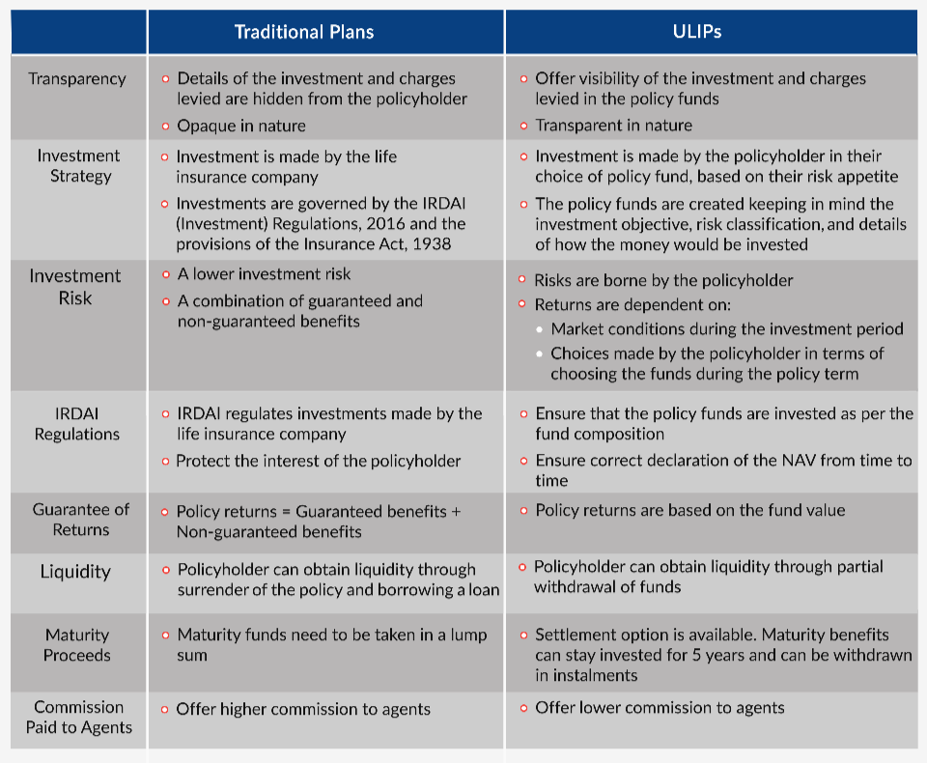

1.Traditional:

* Invests premium collected in govt and approved securities as approved by IRDAI.
* Include term,endowment,money back and whole life policy .
* Par – SA + Guaranteed Additions + Bonus and Non Par Plans- SA + Guaranteed Additions.

2.ULIPs

* Partial Withdrawl option is available
* Manage investments risk – Premium Redirection and Fund switch options are available
* Sum Assured : MIN( 10*Annual regular premium) and MAX( 40* Regular premium paid)
* Maturity Benefit : Fund Value ,which can be received in lump sum or installments, But should be completed in next 5 years.
* Death benefit :

1. higher of SA / Fund Value
2. SA + Fund Value

* Risk charges increase with the age

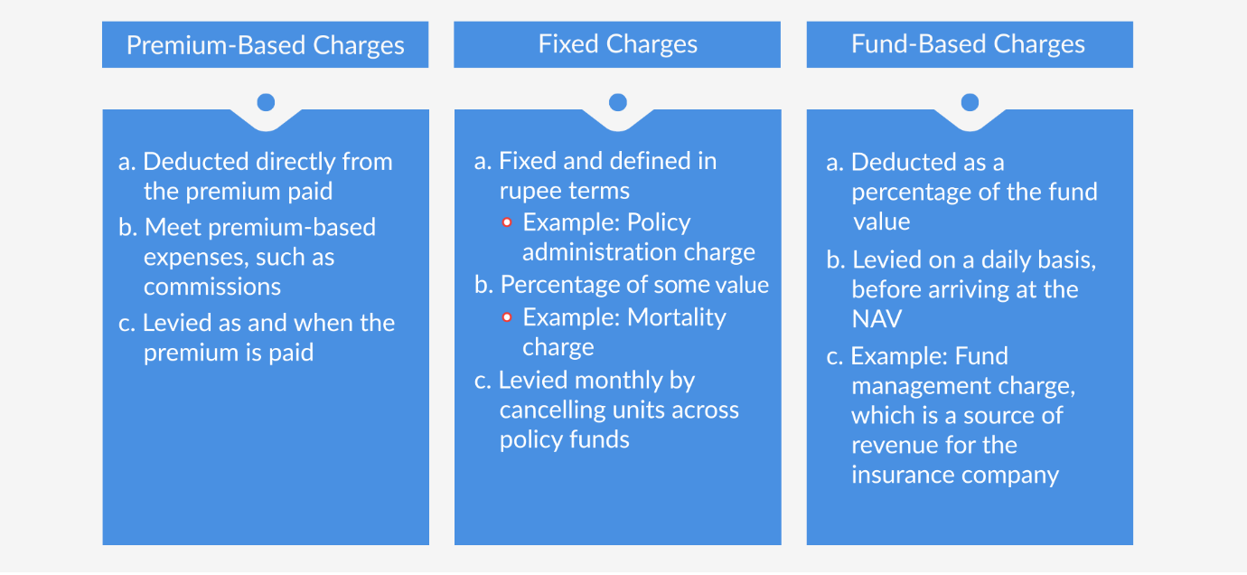

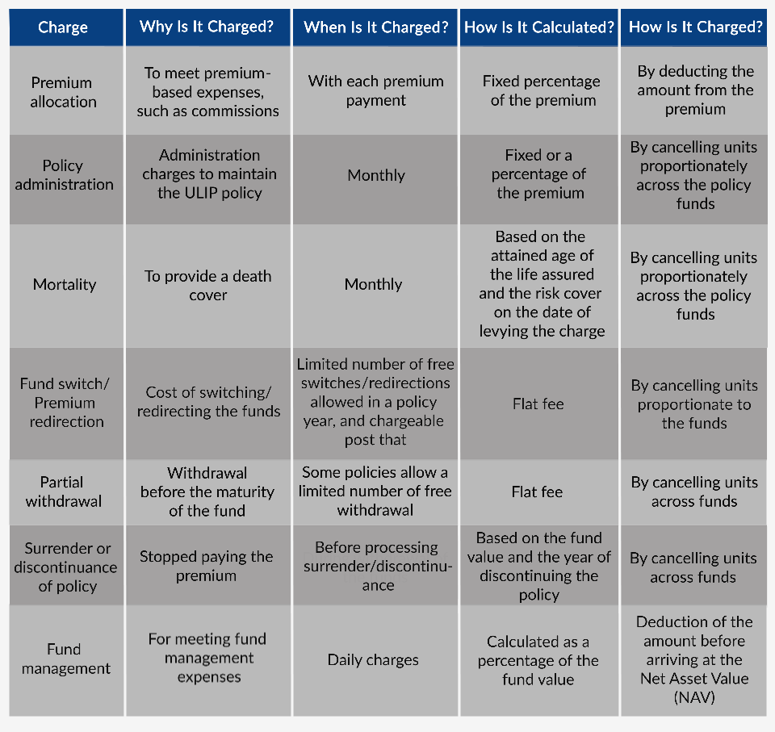

**HLV :** 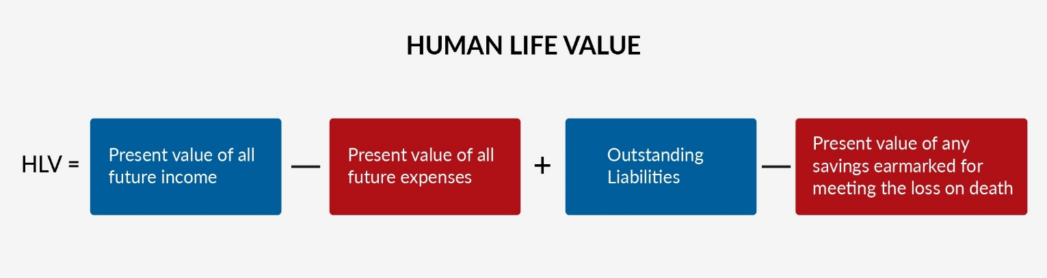

**POLICY ISSUE AND SERVICING:**

Prospect to Policy

CCR – Consultant confidential report which is made while observing the nature/body fitness etc. Made by salesperson only being first underwriter and this helps in assessing the risk.

**LOGIN-CONVERSION STAGES**

* First, the sales professional fills and submits the online application form.
* Second, the proposer’s pre-conversion verification, or PCVC, is done.
* Third, a payment request is generated for the customer.
* Fourth, the sales professional uploads all the important documents needed for the policy conversion.
* Fifth, payment receipting is completed. This amount is adjusted with the premium payment after the policy is converted.

**STEP 1:** You also learnt about the various information fields that are to be carefully filled in the application form for successful conversion of the application. This information includes:

* Customer details,
* Payment details,
* Nominations details,
* CCR details,
* One-page addendum
* Document submission, and
* CCD

You were introduced to the term **Further Requirements** (FR) in the documents submission field. Level 1 FRs are generated where the customer is asked to submit additional documents in order to provide HDFC Life with all the required information for successful processing of the insurance application.

**STEP2** : INSTAVerify– used in PCVC

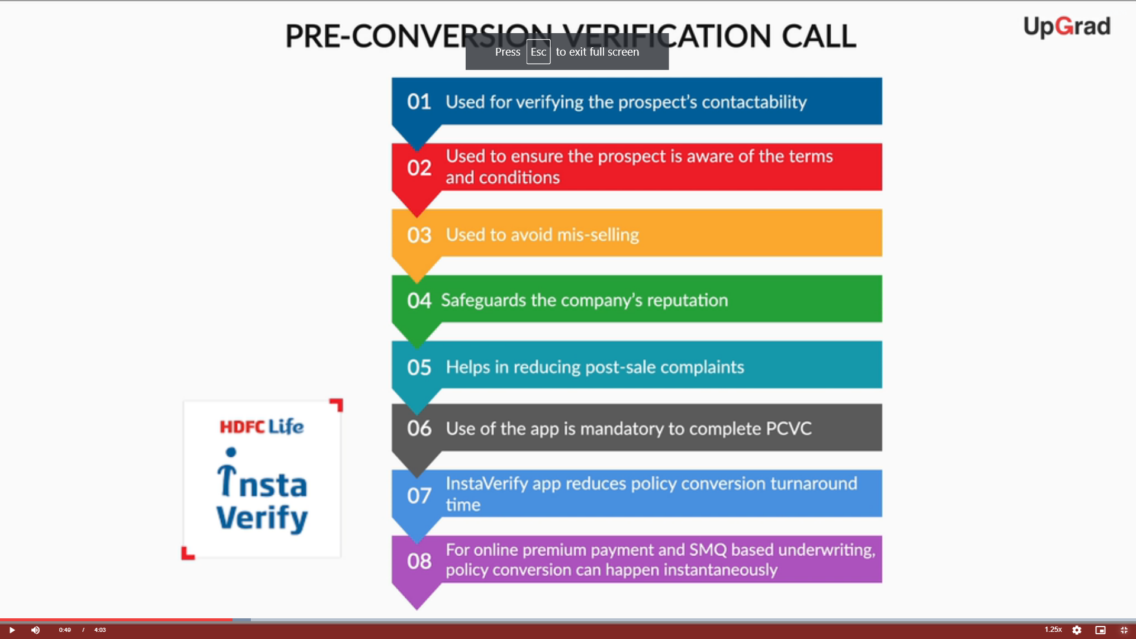

Insta Life and Insta MSD in CCD(Customer Consent Document)

**STEP 3: Payment request**

**STEP4 : Uploading documents**

* **OSV (**Originally seen and verified ) by sales personnel
* Insta FR and I msd used in OSV
* Furtehr Requests(FRs) have to be uploaded with OSV in some cases.

**Step 5 : Payment Reciept**

After dispatch of policy , policy servicing starts.

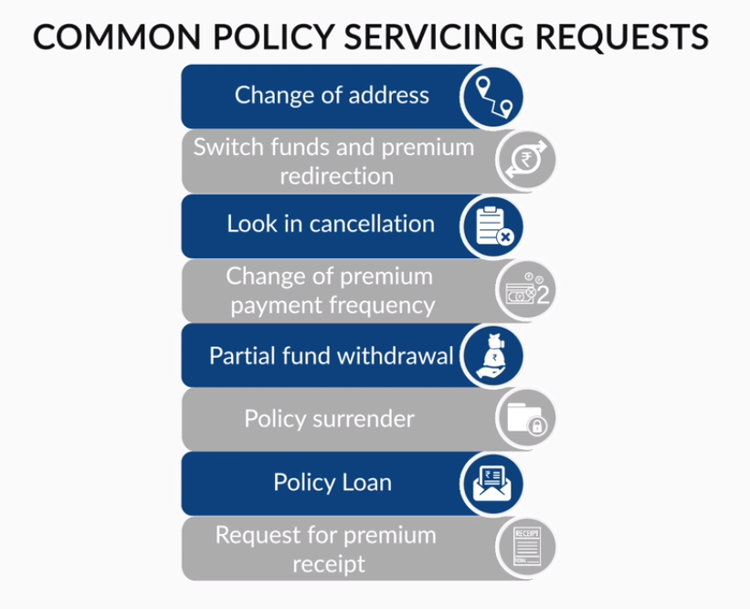

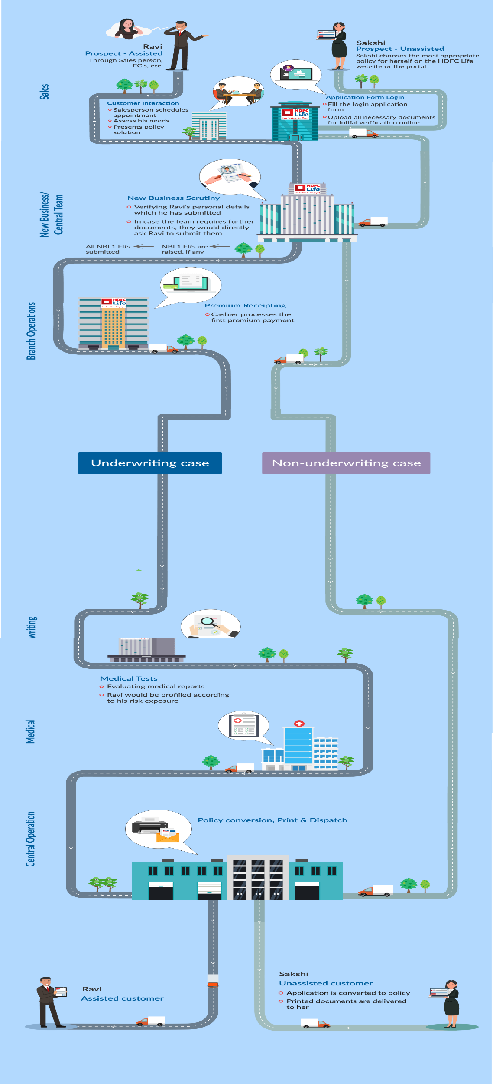

Underwriting and medical test stage is not always required .

In Underwriting risk profiling is done , The underwriting team analyses the medical reports of proposers, measures and quantifies the risk of the proposer according to the analysis and then profiles them according to their risk exposures.

**PRE-SALES APP**

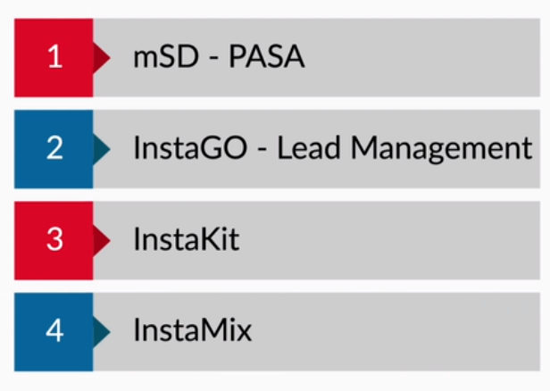

Msd – cross selling the existing customers

InstaGo – Partner Vists tracker.

Insta kit – Knowledge house of all insurance products, funds current performance(ULIP) ,benchmarking .

InstaMix- solutions to customers needs and enables the salesperson to pitch the benefits as per the prospects needs.

**SALES APP**

MSD – From getting leads >>qouting>>complete propsal form >>transfer payment>>Upload documents>>

Instaverify – PCVC to avoid mis selling

Instalife – getting more customers anywhere anytime ,seamless selling process.

Insta – Policy details,Switching to other apps,Products, Chat box.

InstaFR – Submitting documents of customers without going to branch

**POST SALES APPS**

Insta Serve – to serve the policy related requests easily and anywhere.

**DISTRIBUTION CHANNEL**

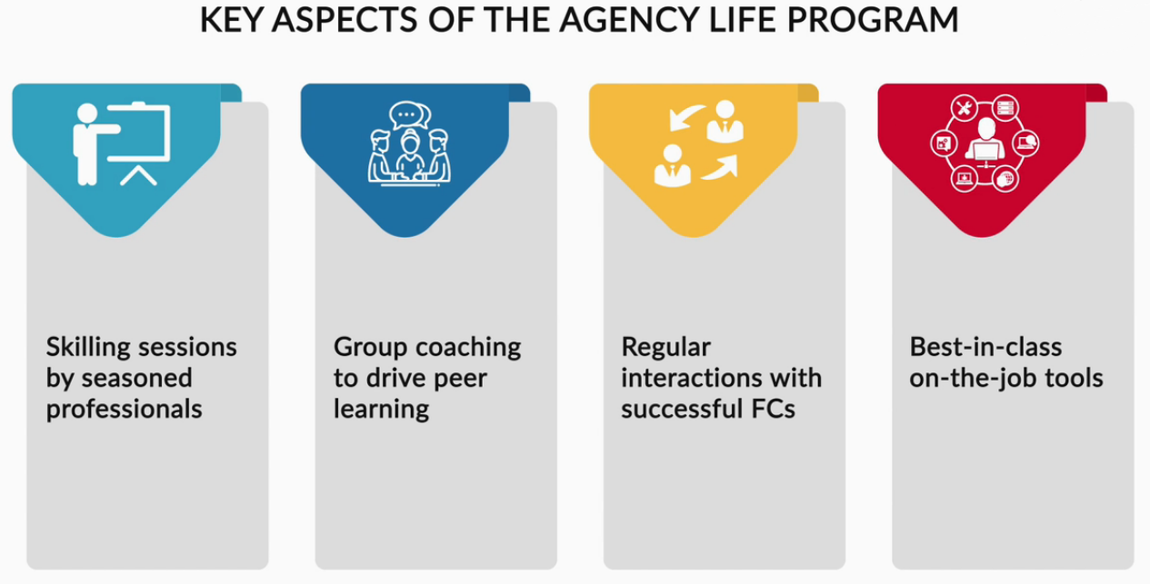

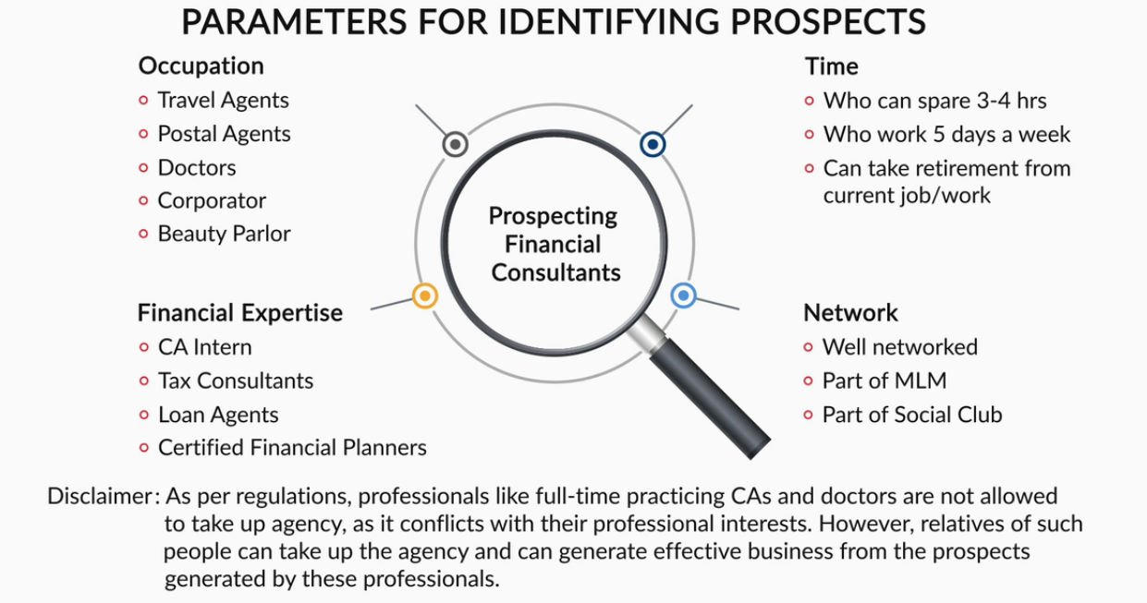

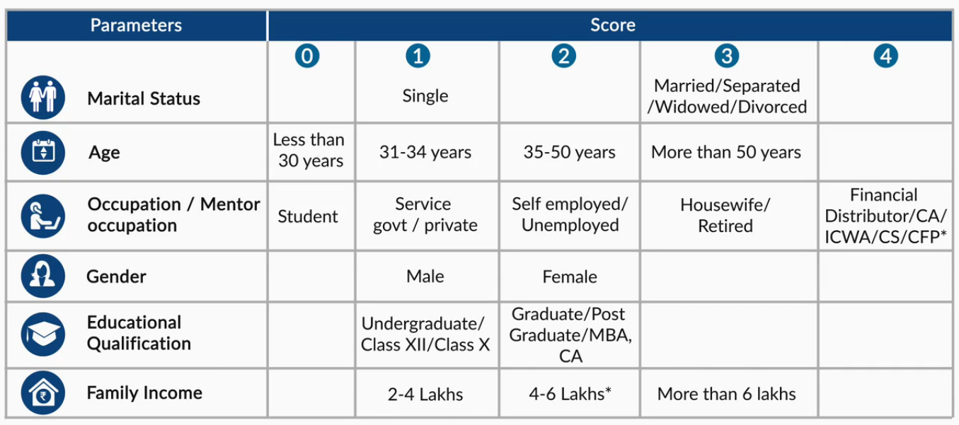

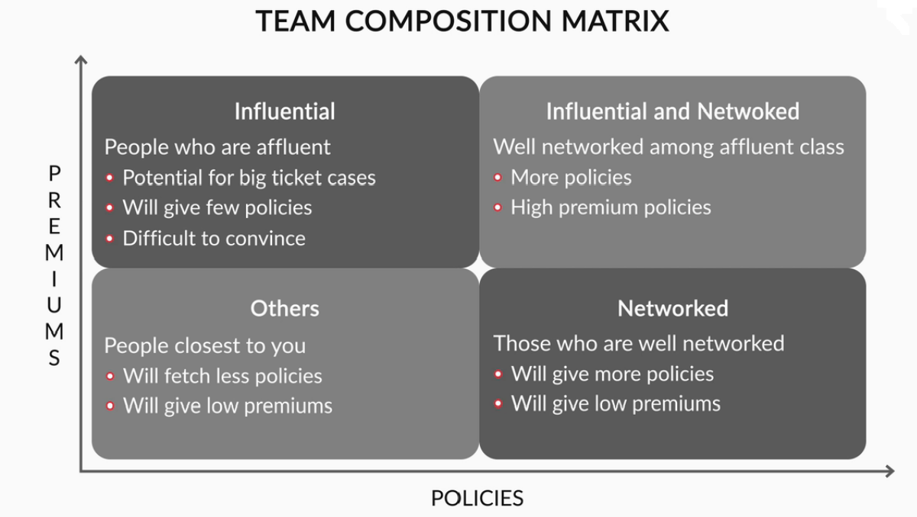

**Bancassurance :** The bancassurance channel works on a corporate agency model, in which a life insurance company ties up with banks and corporate agents to sell insurance to their customers.

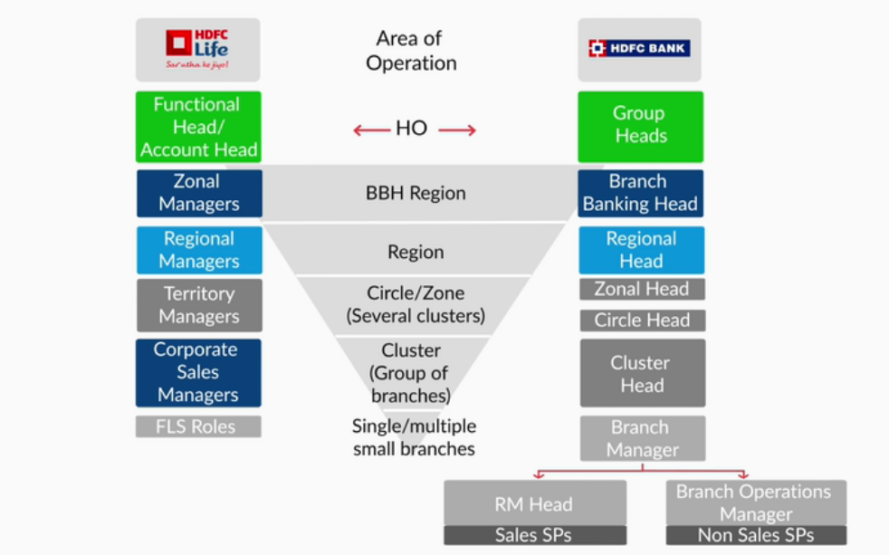

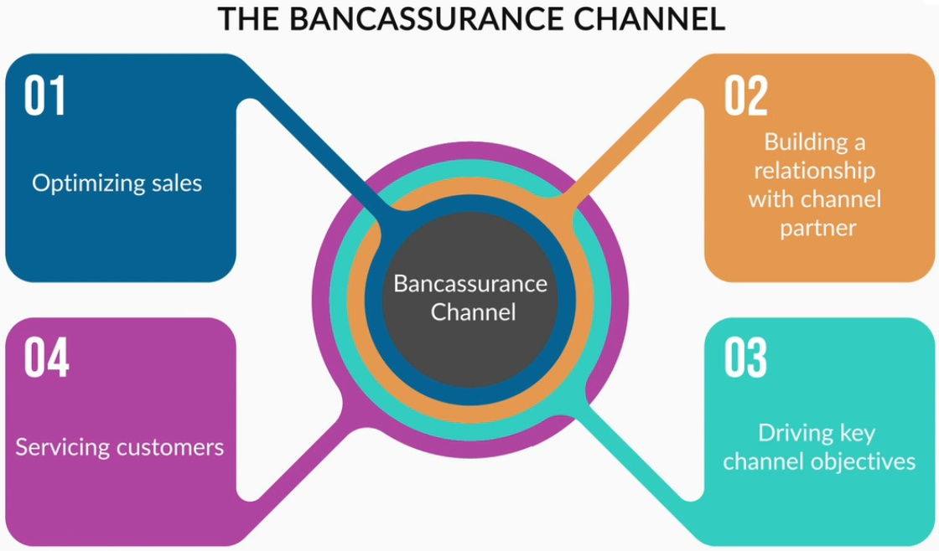

S.T.A.R., which stands for Sales Team Appraisal and Review, is the framework used at HDFC Life to review your performance against your set goals and targets.

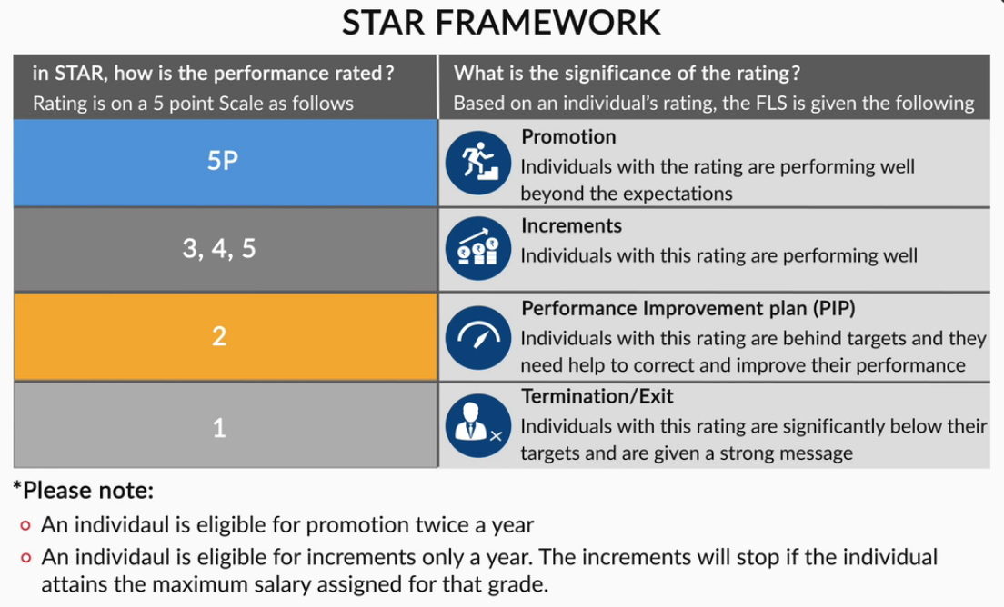

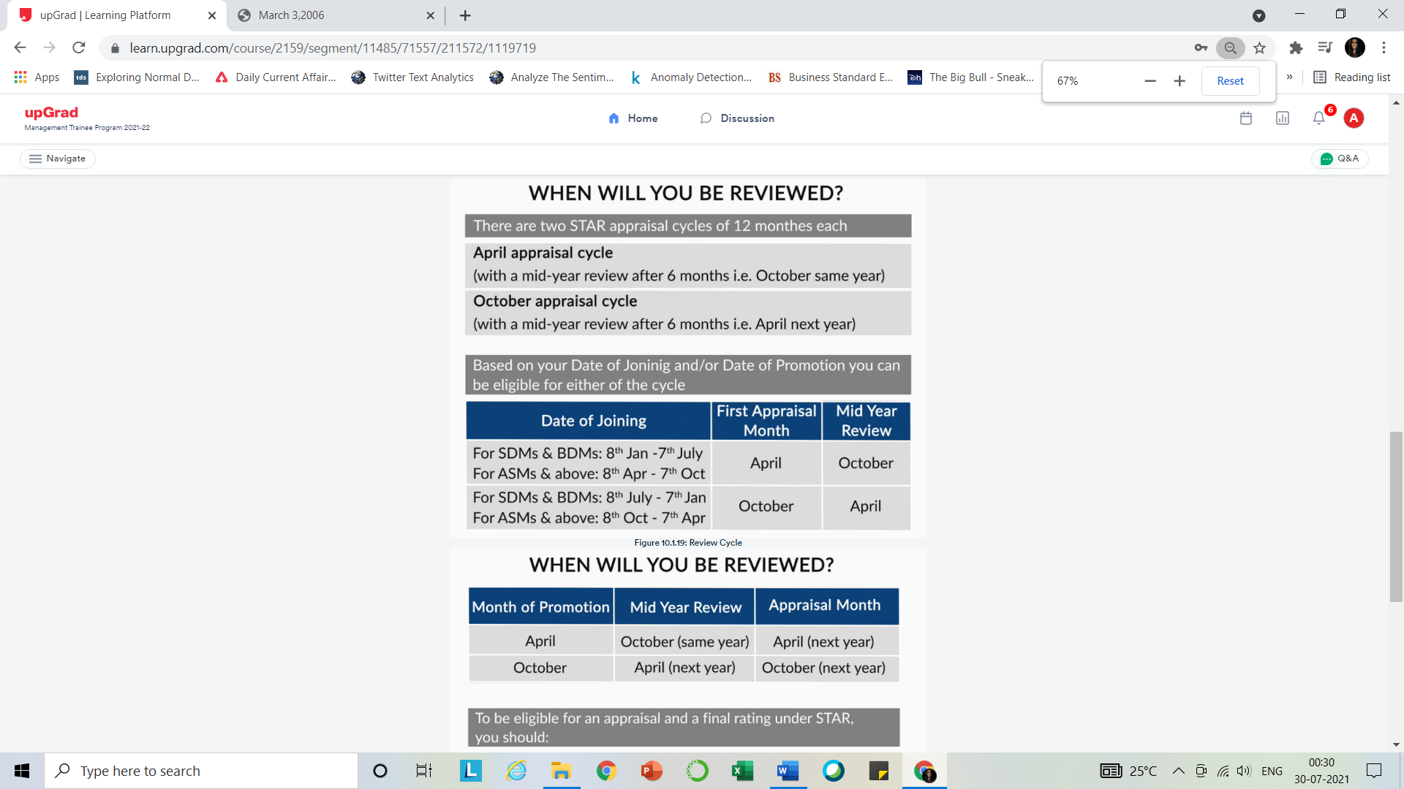

**PLANS**

* 1. **Click2protect 3D PLUS**
* Non par +Term
* 3 options – life(term illness leading to death in 6 months),3d Life (+Critical Illness covered+ accidental disability) , Extra Life( +Accidental Death Covered)
* Income Option – S.A +income after death till policy continues.
* Return Of premium option
* Life stage Protection – increase the SA at marriage/child
* Top-up options

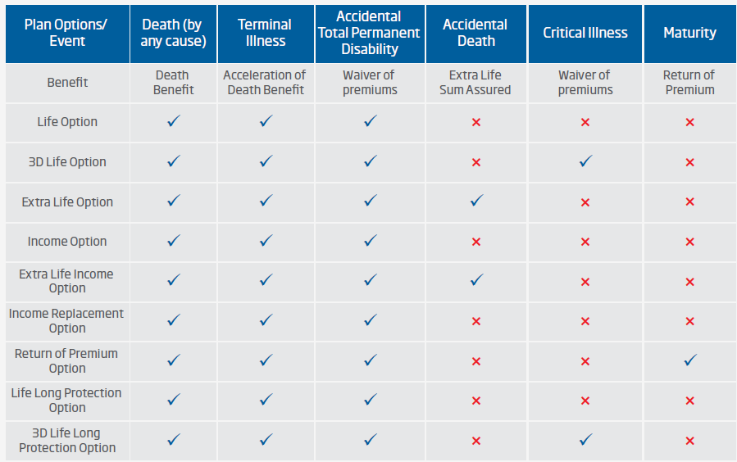

**Sampoorn Smariddhi Plan**

* NON LINKED,Participating and savings
* Savings + Potection
* 2 options - endowmwnt +ew with whole life

**Regulatory Environment**

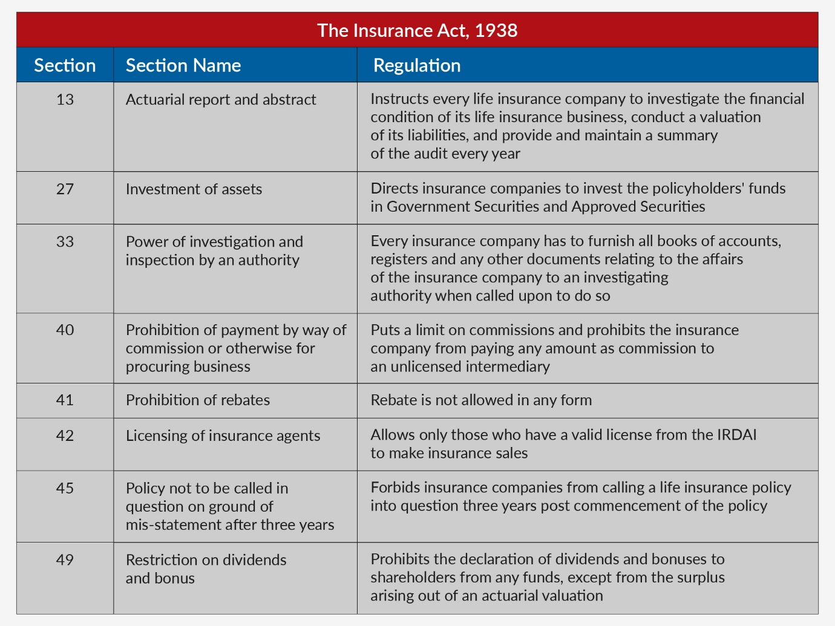

Finance Intelligence unit of India – for suspicious financial transactions.

